**Pizza Sales SQL Queries**

**KPI’s**

**1.Total Revenue**

SELECT SUM(TOTAL_PRICE) AS Total_Revenue FROM pizza_sales

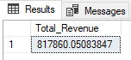

**2.Average Order Value**

SELECT SUM(TOTAL_PRICE) / COUNT(DISTINCT ORDER_ID) AS Average_Order_Value FROM pizza_sales

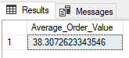

**3.Total Pizza Sold**

SELECT SUM(QUANTITY) AS Total_Pizza_Sold FROM pizza_sales

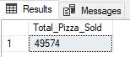

**4.Total Orders**

SELECT COUNT(DISTINCT order_id) AS Total Orders FROM pizza_sales

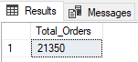

**5.Average Pizza Per Order**

SELECT CAST(CAST (SUM(QUANTITY) AS decimal(10,2))/CAST(COUNT(DISTINCT order_id) AS DECIMAL (10,2)) AS DECIMAL(10,2))AS Average_Pizza_Per_Order FROM pizza_sales

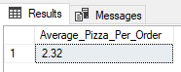

**CHARTS**

**1.Daily Trend For Total Orders**

SELECT DATENAME(DW,ORDER_DATE) AS ORDER_DATE, COUNT (DISTINCT ORDER_ID)

AS TOTAL_QUANTITY FROM pizza_sales

GROUP BY DATENAME(DW,ORDER_DATE)

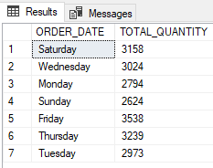

**2.Monthly Trend For Total Orders**

SELECT DATENAME(MONTH,ORDER_DATE) AS Month Name, COUNT (DISTINCT ORDER_ID)

AS Total Orders

FROM pizza_sales

GROUP BY DATENAME(MONTH,ORDER_DATE)

Order by Total Orders desc

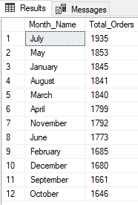

**3.Percentage Of Sales By Pizza Category**

Select Pizza Category, CAST(SUM(total price)*100/(Select SUM(total price)

From pizza_sales) AS DECIMAL(10,2))As Percentage_Of_Total_Price

From pizza_sales

Group By Pizza Category

Order by Percentage_Of_Total_Price desc

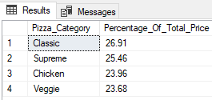

**4.Percentage Of Sale By Pizza Size**

SELECT pizza size, CAST(SUM(TOTAL_PRICE)*100/ (SELECT SUM(TOTAL_PRICE)

FROM pizza_sales) As DECIMAL(10,2)) AS Percentage_Of_Sales_By_Pizza_Size

FROM PIZZA_SALES

GROUP BY pizza size

ORDER BY Percentage_Of_Sales_By_Pizza_Size Desc

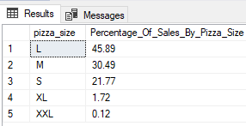

**5.Total Pizza Sold By Pizza Category**

Select pizza category, sum(quantity) as Total_Pizzas_Sold

From pizza_sales

Group By pizza_category

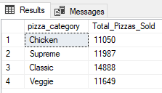

**6. Top 5 Pizzas by Revenue**

Select Top 5 pizza_name, cast(sum(total price) as decimal(10,2)) As Total Revenue

From pizza_sales

Group By pizza_name

Order by Total Revenue Desc

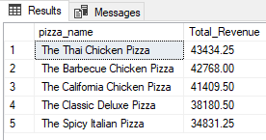

**7. Bottom 5 Pizzas by Revenue**

Select Top 5 pizza_name, cast(sum(total price) as decimal(10,2)) As Total Revenue

From pizza_sales

Group By pizza_name

Order by Total Revenue Asc

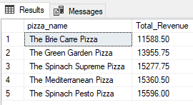

**8. Top 5 Pizzas by Quantity**

Select Top 5 pizza_name, sum(quantity) As Total_Quantity

From pizza_sales

Group By pizza_name

Order by Total_Quantity Desc

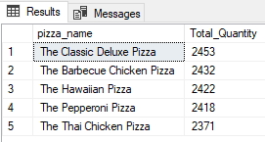

**9. Bottom 5 Pizzas by Quantity**

Select Top 5 pizza_name, sum(quantity) As Total_Quantity

From pizza_sales

Group By pizza_name

Order by Total_Quantity Asc

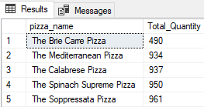

**10. Top 5 Pizzas by Orders**

Select Top 5 pizza_name, Count(Distinct order_id) As Total_Order

From pizza_sales

Group By pizza_name

Order by Total_Order Desc

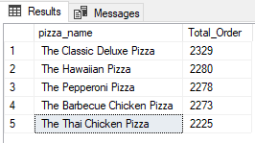

**11. Bottom 5 Pizzas by Orders**

Select Top 5 pizza_name, Count (Distinct order_id) As Total_Order

From pizza_sales

Group By pizza_name

Order by Total_Order Asc

